Project Design Phase-II
Technology Stack (Architecture & Stack)

Date | 6 February 2026
Team ID | LTVIP2026TMIDS57703
Project Name | Civil Engineering Insight Studio
Maximum Marks | 4 Marks

Technical Architecture:
The Deliverable includes the architectural diagram as below and the information as per the table1 & table 2
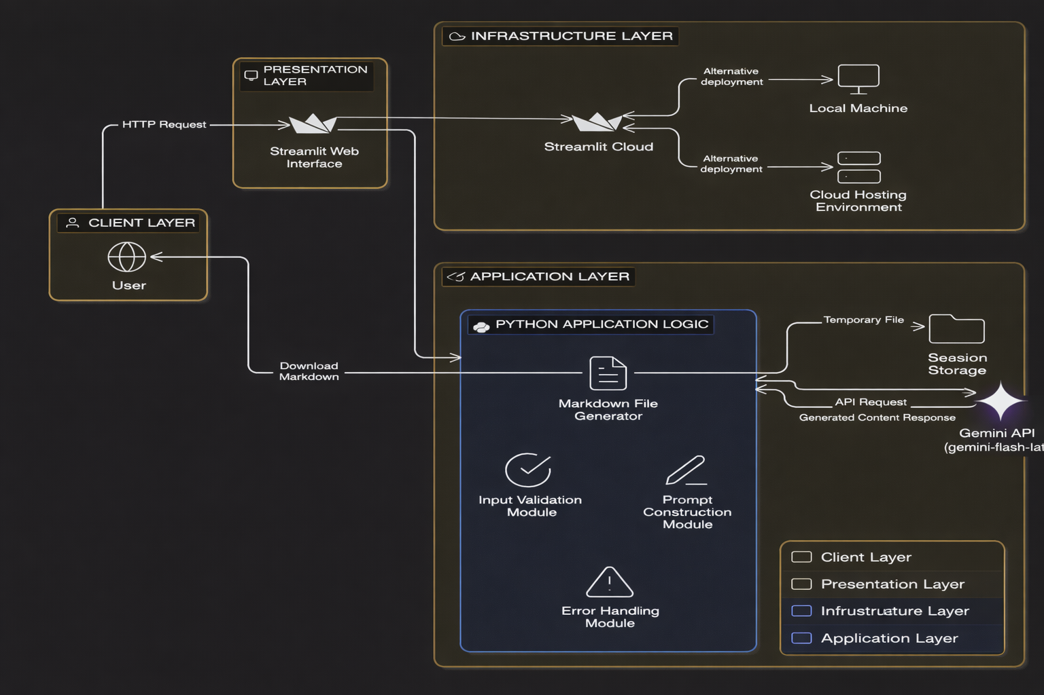
Table-1 : Components & Technologies:
S.No | Component | Description | Technology
 | User Interface | Web-based interface where users upload construction images, enter analysis request, and view generated structural report. | Streamlit (Python-based Web UI)
 | Application Logic-1 | Handles image upload, user input validation, and workflow control. | Python
 | Application Logic-2 | Prompt construction logic for structured civil engineering analysis. | Python (Prompt Engineering Logic)
 | Application Logic-3 | AI-powered structural analysis via external model integration. | Google Gemini API (gemini-flash-latest)
 | Database | No persistent database used (stateless application). | Not Applicable
 | Cloud Database | Not used in current implementation | Not Applicable
 | File Storage | Temporary storage of generated report during session runtime. | Local Runtime (Streamlit Session State)
 | External API-1 | AI-based multimodal analysis (Image + Text). | Google Gemini API
 | External API-2 | Not used | Not Applicable
 | Machine Learning Model | Large Multimodal Language Model for structural description and analysis. | Gemini Vision / Gemini Flash Model
 | Infrastructure (Server / Cloud) | Application can be deployed locally or on cloud hosting platforms. | Local System / Streamlit Cloud / Python-supported Cloud Environment

Table-2: Application Characteristics:
S.No | Characteristics | Description | Technology
 | Open-Source Frameworks | Framework used to build and deploy the web interface | Streamlit (Open-source Python framework)
 | Security Implementations | API key secured using environment variables (.env) or Streamlit secrets; no sensitive user data stored. | python-dotenv / Streamlit Secrets
 | Scalable Architecture | Stateless architecture; scalability depends on hosting environment and Gemini API limits. | Streamlit + Cloud Hosting
 | Availability | Application availability depends on hosting platform uptime. | Streamlit Cloud / Cloud Hosting Provider
 | Performance | AI analysis response time depends on Gemini API latency; lightweight UI ensures minimal frontend delay. | Python + Gemini API

